Project : 1

Terraform is an open-source infrastructure as a CODE (IAC) tool that allows to create, manage & deploy the production- ready environment. In this project, we will deploy a three- tier application in aws using terraform.

Step -1 : create a file for the provider by using .tf

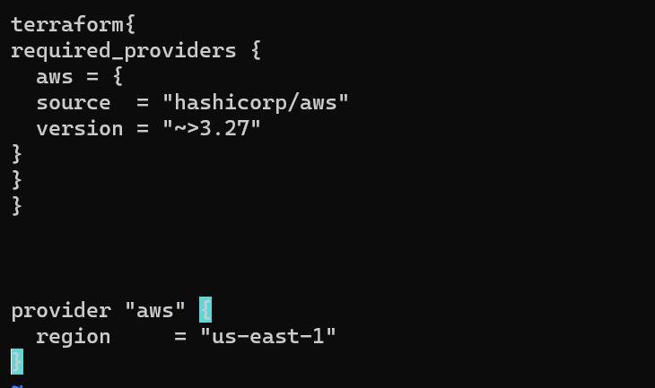

Step -2 : first of all install terraform in your server by using Linux commands.

* sudo yum install -y yum-utils shadow-utils

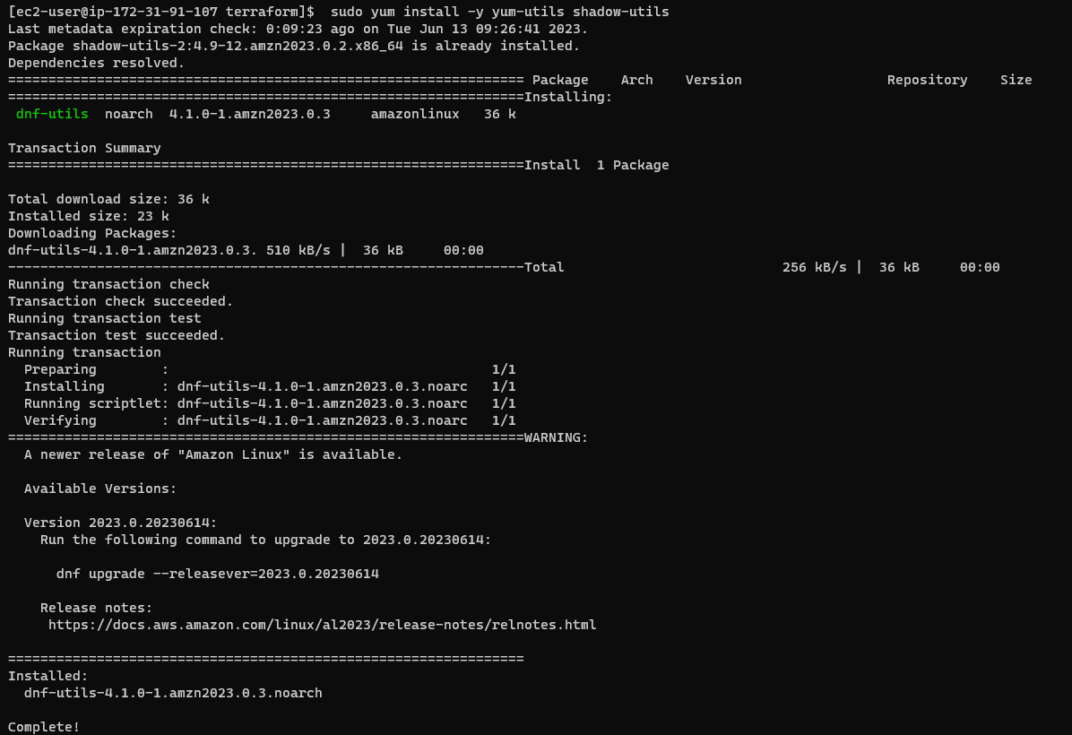

* sudo yum-config-manager --add-repo <https://rpm.releases.hashicorp.com/AmazonLinux/hashicorp.repo>.
* sudo yum -y install terraform.

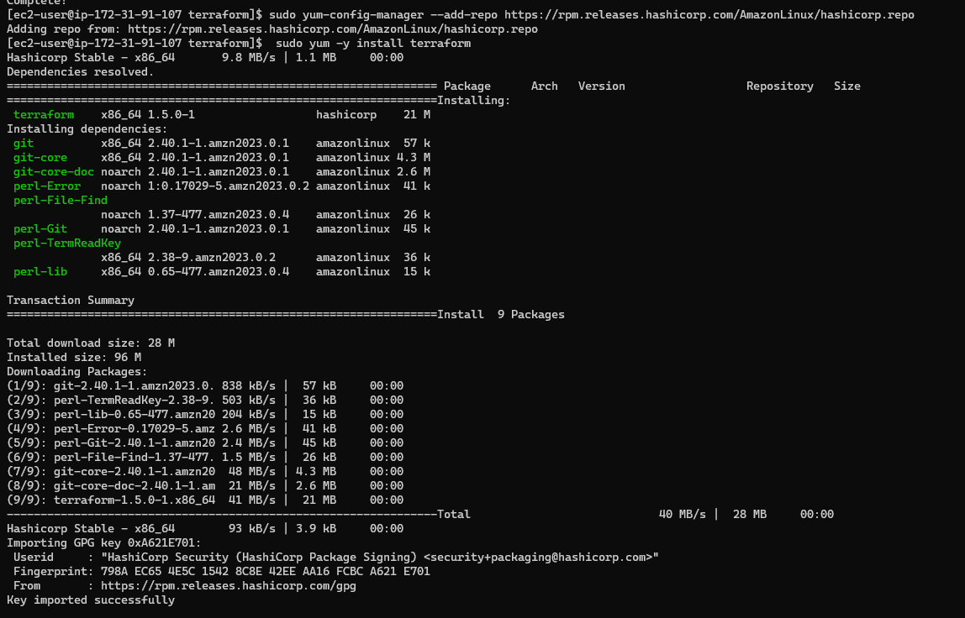

Step -3 : create a file for the VPC with the extension of .tf

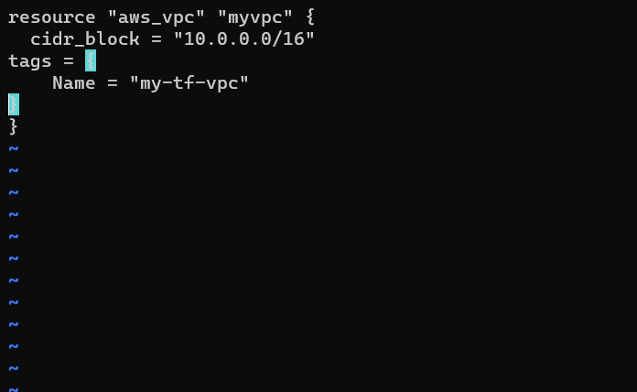

* this is the graphical user interface of VPC which we have created by using .tf extension in command line interface.

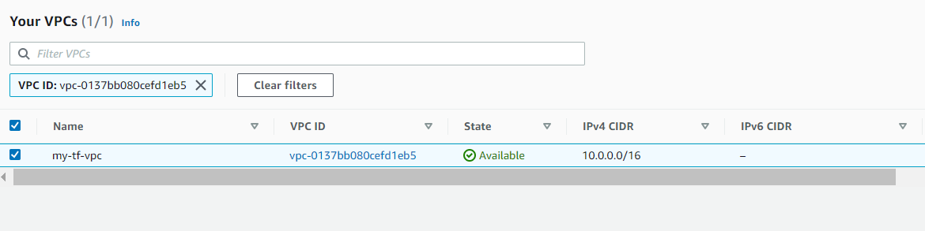

Step -4 : create a file for the SUBNET with the extension of .tf

* Here I create 2 public subnets and 2 private subnets.

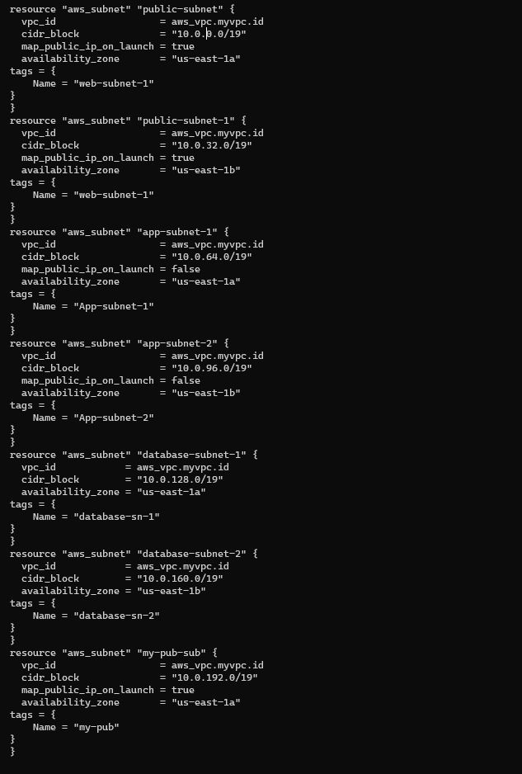

* Here I created 2 database subnets.



* This is the graphical user interface of the subnets which we have created using .tf extension in command line interface.

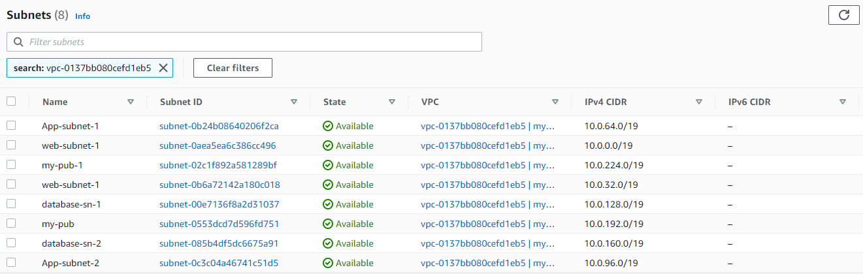

Step -5 : Create a file for the internet Gateway with the extension of .tf

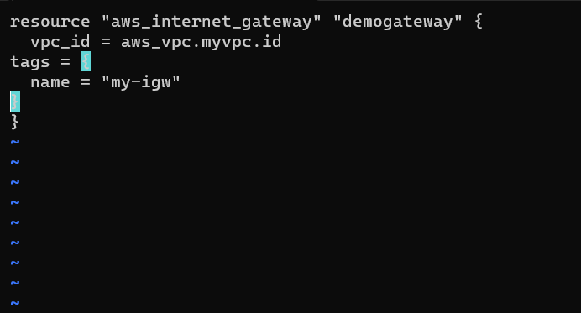

* This is graphical user interface of the internet gateway which we have created by using .tf extension in command line interface.

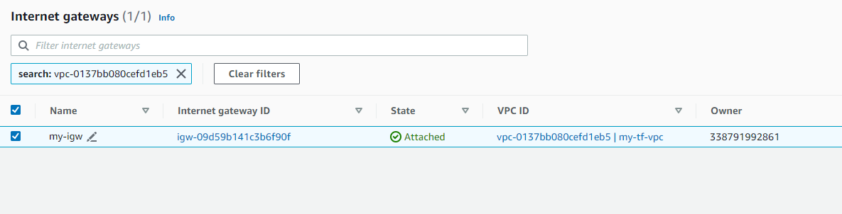

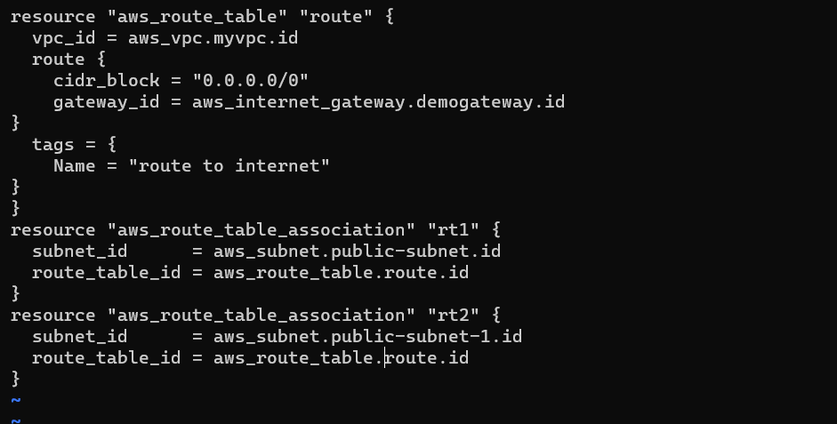

* Create a file for the route tables with extension of .tf (private)

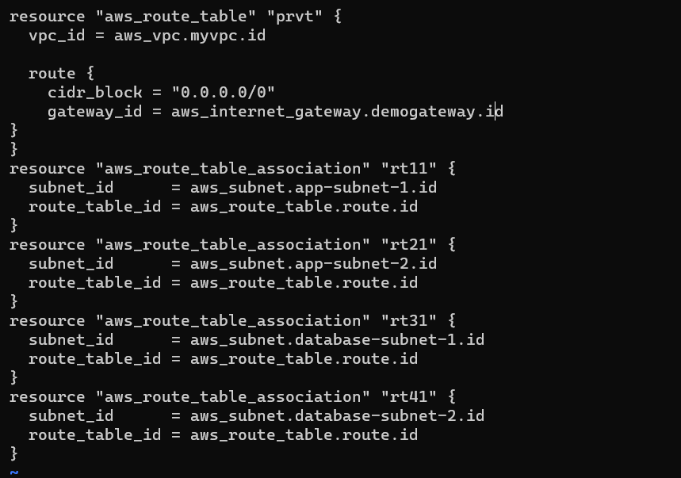

* This is graphical user interface of the route tables which we have created by using .tf extension in command line interface.

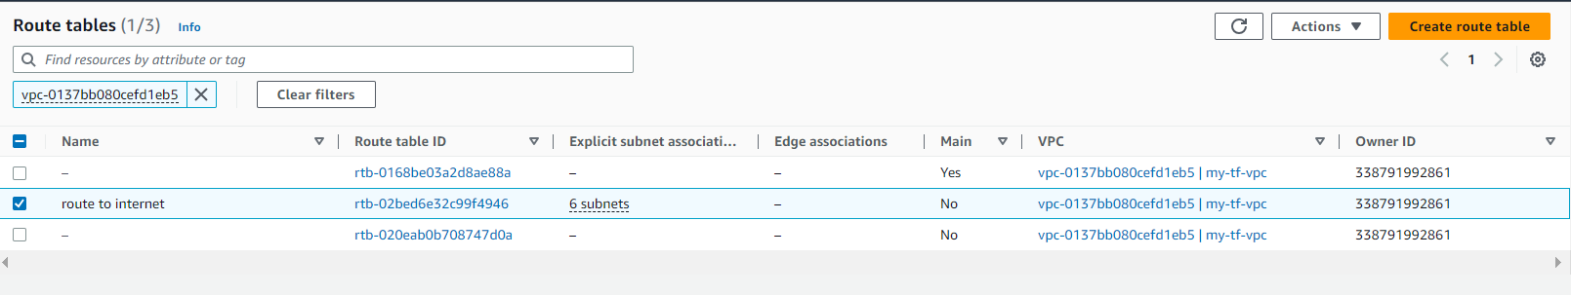

* Create a file for security group for the front-end tier.

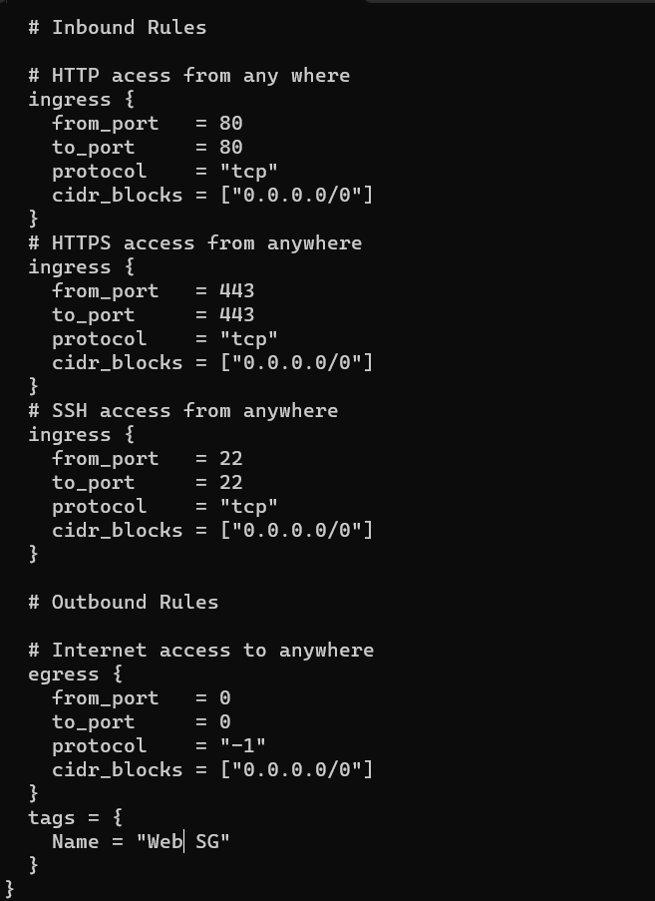

* This is graphical user interface of the route tables which we have created by using .tf extension in command line interface.

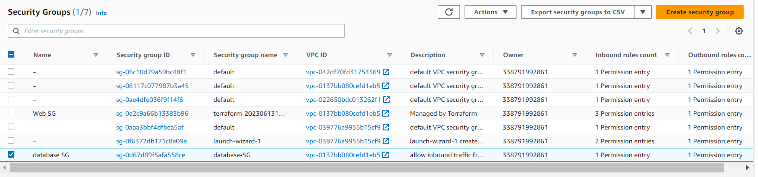

* Create a file for security group for the Database tier.

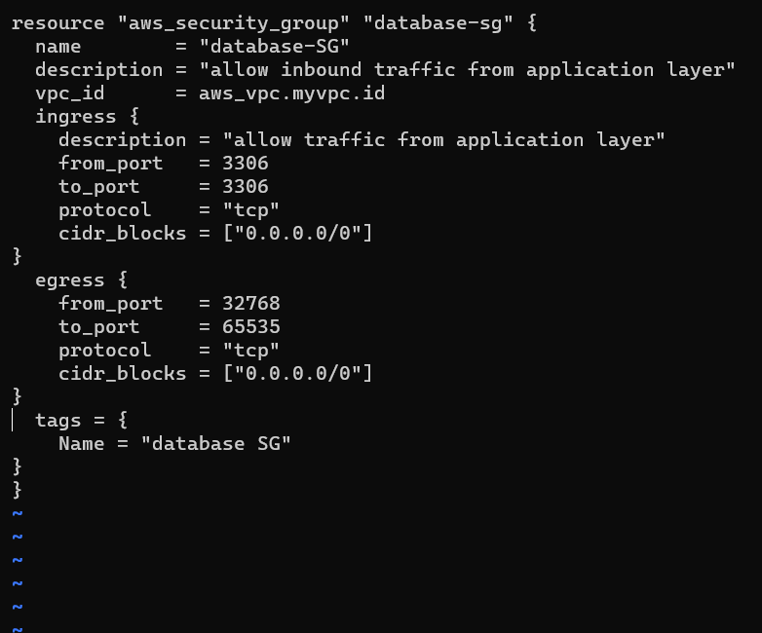

* Create a file for ec2 instance using .tf extension.

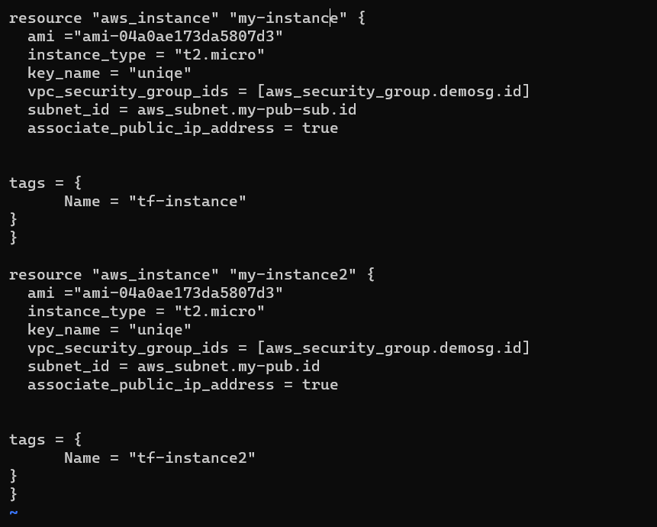

* This is graphical user interface of the ec2 instance which we have created by using .tf extension in command line interface.

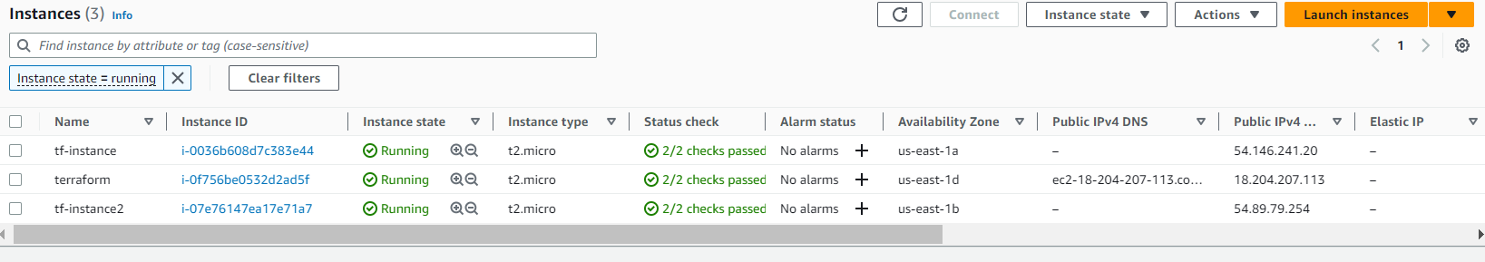

* Create a file for user data.

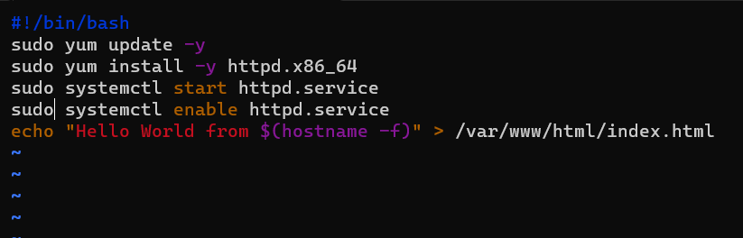

* Create a file for RDS instance

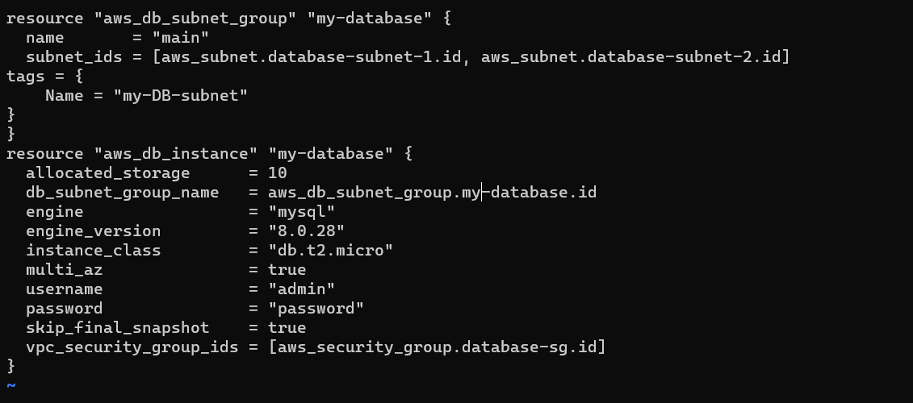

* This is graphical user interface of the RDS instance which we have created by using .tf extension in command line interface.

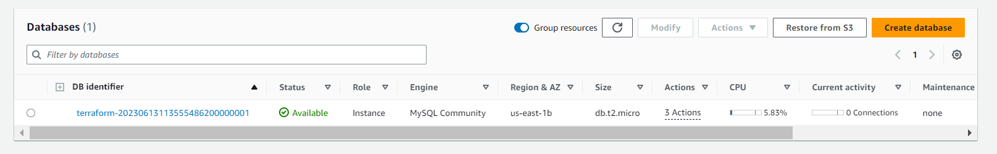

* Create a file for application load balancer

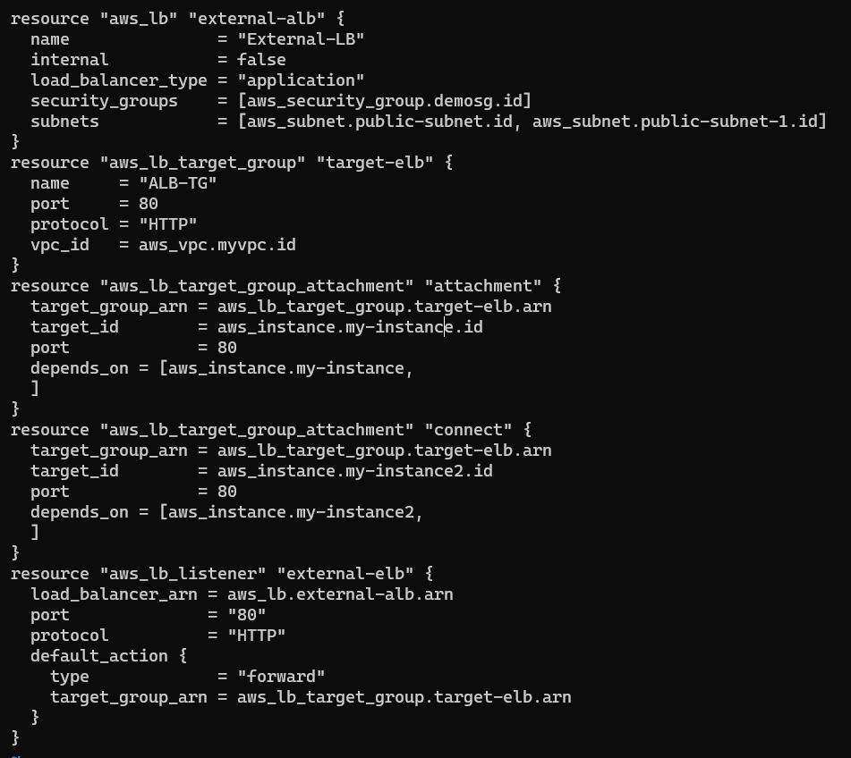

* This is graphical user interface of the application load balancer which we have created by using .tf extension in command line interface.

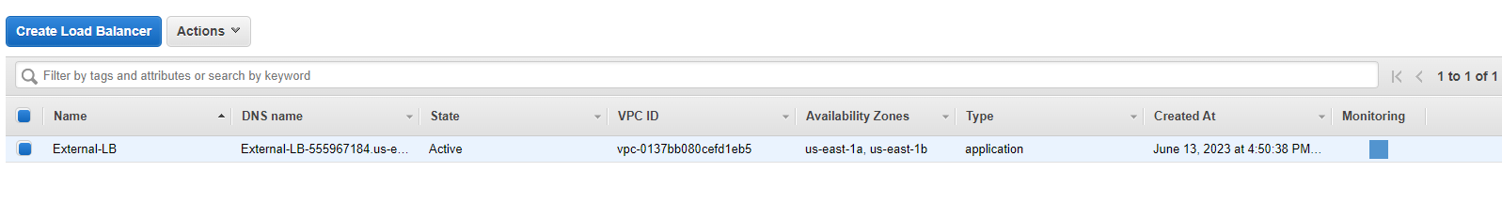

* Create a file for outputs.

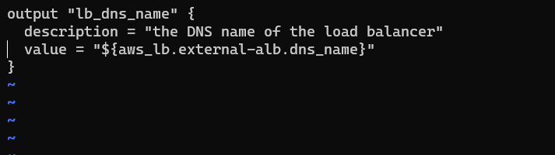

* Output on website by using IP address from EC2 instance.

